SIMATS ENGINEERING
ASSESSMENT TOOL 3

COURSE NAME: Artificial Intelligence COURSE CODE: CSA17

COURSE OUTCOME COVERED

CO2: Experiment search and game-solving techniques such as Greedy Search, A*, CSP, Minimax, and Alpha-Beta pruning with heuristic functions for solving complex AI problems efficiently. (BL3)

Assessment Tool Weightage: 40%

Duration: 1 Hour
QUESTIONS: 3 Total Marks:30

Annexure A

Dry Run Evaluation

Code of Conduct:

I N.JOE JERISH(192524374) (Name / Reg No) certify that this submission is my original work and that I have adhered to the guidelines specified for this assessment.
I understand that any violation of academic integrity rules will result in disciplinary action.

Signature of the student:

Annexure A

Dry Run Evaluation
1. Question 1 – Breadth-First Search (BFS)
Consider the following graph: A
/ \
B C
/ \ / \
D E F G
Task: Starting from node A, perform a Breadth-First Search (BFS). Complete the following table.
Iteration | Queue | Visited Node
1
2
3
4
5
6
7
Questions:
- Write the BFS traversal order.
- Show the queue contents after each iteration.

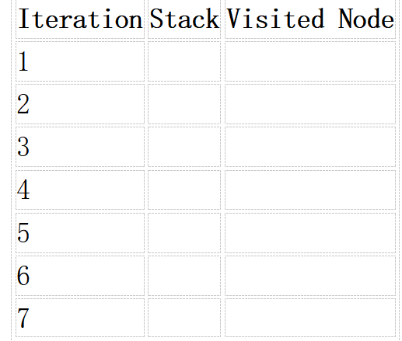
2. Depth-First Search (DFS) Using the same graph,
A
/ \
B C
/ \ / \
D E F G
Perform Depth-First Search (DFS) starting from A.
Complete the table.
- Initial State :
1 3 6
5 0 2
4 7 8

Goal State :
1 2 3
4 5 6
7 8 0

Task
Trace Breadth-First Search (BFS) until the goal state is reached.
Fill in the table.
Iteration | Current State | Queue Before Expansion | Queue After Expansion
1
2
3
4
5

Questions
- Which node is expanded in each iteration?
- How many states are generated in total?
- Write the complete solution path from the initial state to the goal state.
- Why does BFS always find the shortest solution in an unweighted 8-puzzle problem?

RUBRICS FOR CALCULATION

Criteria | Weightage (%) | Level 4 – Exemplary (4) | Level 3 – Proficient (3) | Level 2 – Developing (2) | Level 1 – Beginning (1)
Understanding of Search Problem | 20 | Clearly understands the search problem, initial state, goal state, and search strategy. | Understands the problem with minor misunderstandings. | Demonstrates partial understanding of the search problem. | Shows little or no understanding of the search problem.
State Expansion and Dry Run Execution | 30 | Correctly traces every iteration, expands nodes accurately, and maintains the Queue/Stack/Priority Queue without errors. | Performs most iterations correctly with minor mistakes in state expansion or data structure updates. | Performs only some iterations correctly; several errors in tracing or node expansion. | Unable to correctly perform the dry run or expand states.
Application of Search Algorithm | 20 | Applies the selected algorithm (BFS/DFS/UCS) correctly, following all algorithmic rules. | Applies the algorithm correctly with a few procedural errors. | Applies only basic algorithm steps with noticeable mistakes. | Fails to apply the correct search algorithm.
Accuracy of Solution Path | 20 | Identifies the correct traversal order/solution path and goal state with proper justification. | Solution path is mostly correct with minor errors. | Partially correct solution path; goal may not be reached correctly. | Incorrect or incomplete solution path.
Presentation and Logical Reasoning | 10 | Queue/Stack/Priority Queue updates, state diagrams, and explanations are neat, organized, and logically presented. | Presentation is clear with minor organizational issues. | Limited explanation and organization; reasoning is partially clear. | Poor presentation with unclear or missing reasoning.

1.BFS TRANSVERSAL ORDER

PROGRAM:

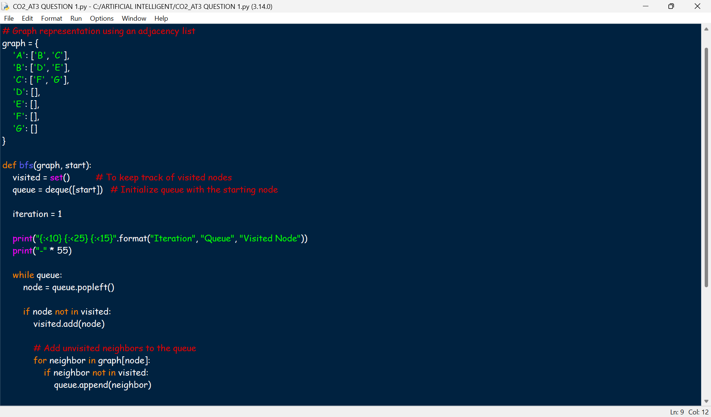
OUTPUT:

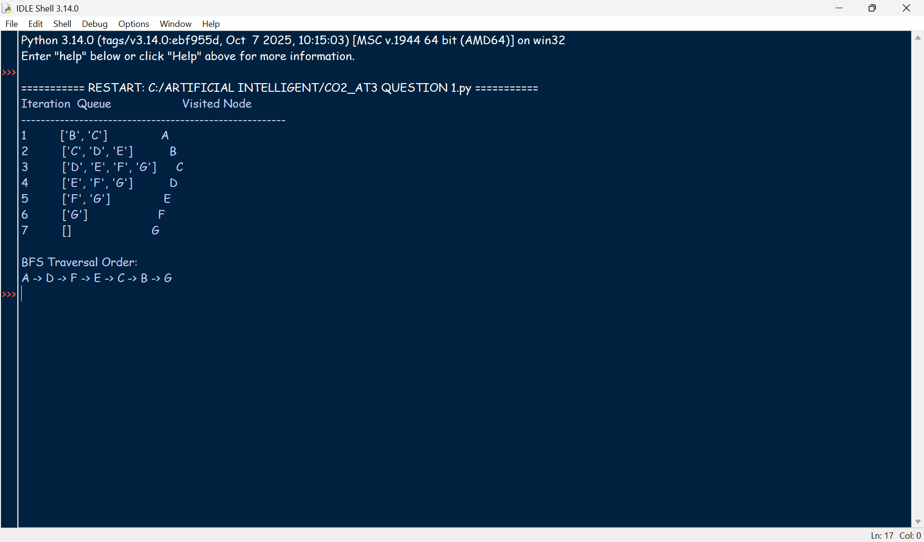

1.BFS Traversal Order: A → B → C → D → E → F → G

2.
Queue Contents After Each Iteration:
Iteration 1: B, C
Iteration 2: C, D, E
Iteration 3: D, E, F, G
Iteration 4: E, F, G
Iteration 5: F, G
Iteration 6: G
Iteration 7: Empty

2. Depth-First Search (DFS)

PROGRAM:

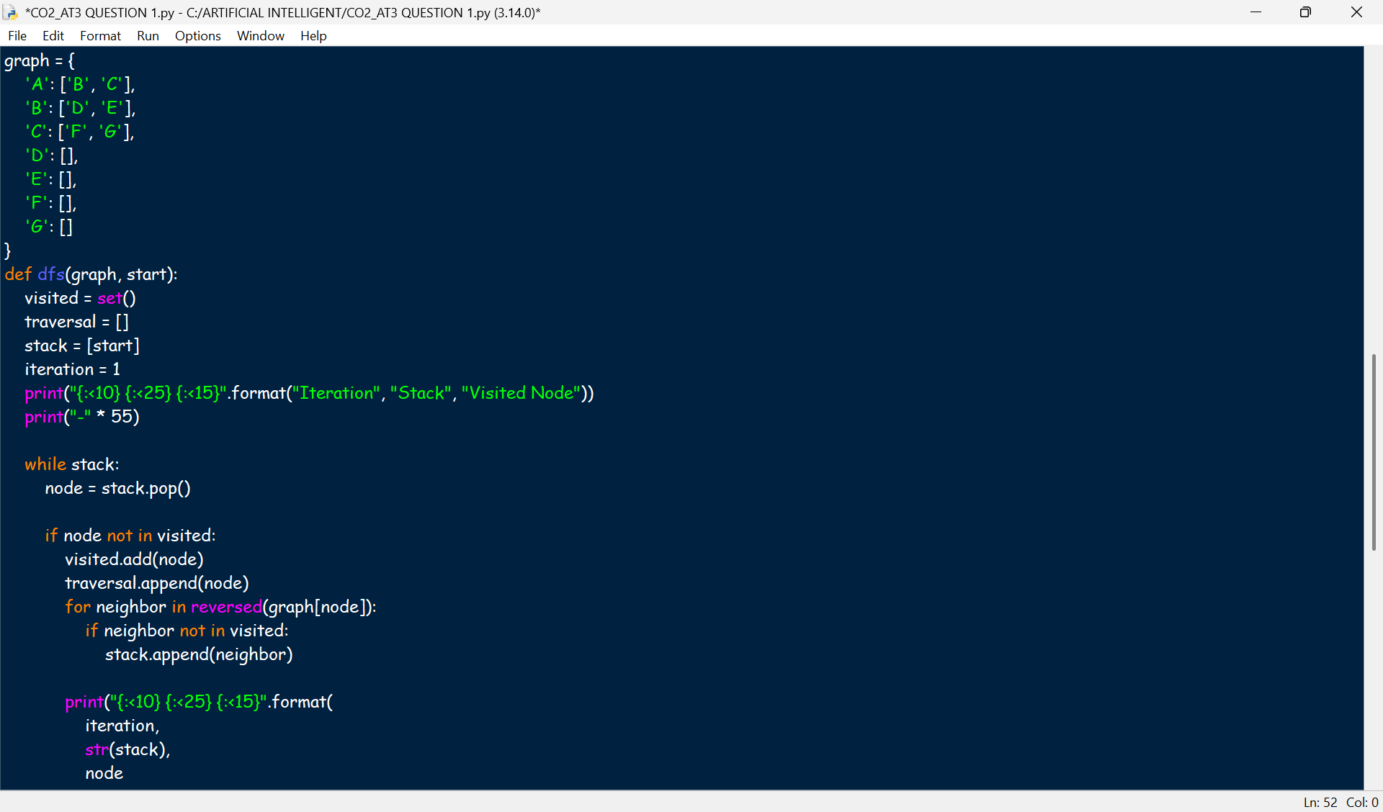

OUTPUT:
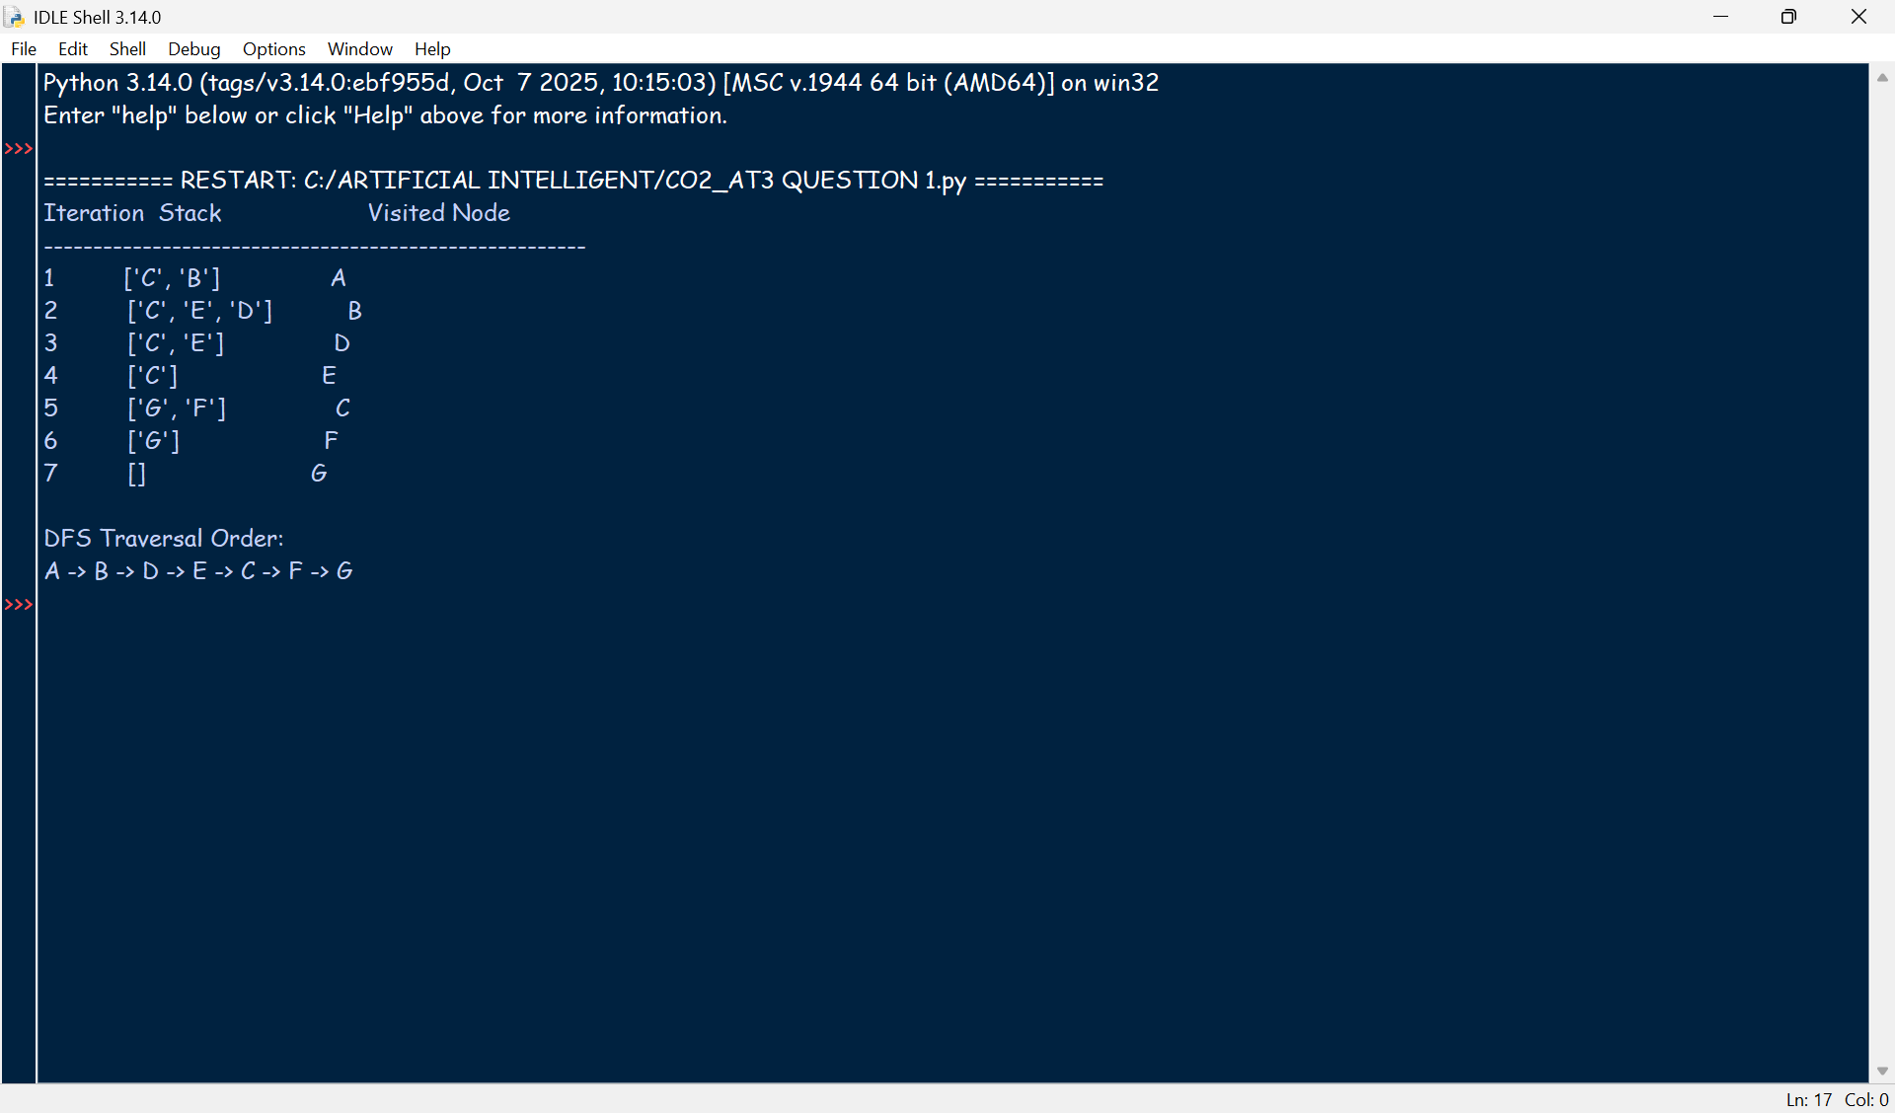
3. Trace Breadth-First Search (BFS) until the goal state is reached.
1. Which node is expanded in each iteration?
The node at the front of the queue (FIFO) is expanded in every iteration.

2. How many states are generated in total?
Not determinable from the given table. BFS will generate dozens or hundreds of states before reaching the goal for this starting configuration.

3. Complete solution path
Cannot be written within the given five iterations because the goal is not reached that quickly.

4. Why does BFS always find the shortest solution?
Because BFS explores all states level by level. Every move has the same cost (one move), so the first time BFS reaches the goal, it has found the minimum number of moves.

PROGRAM:

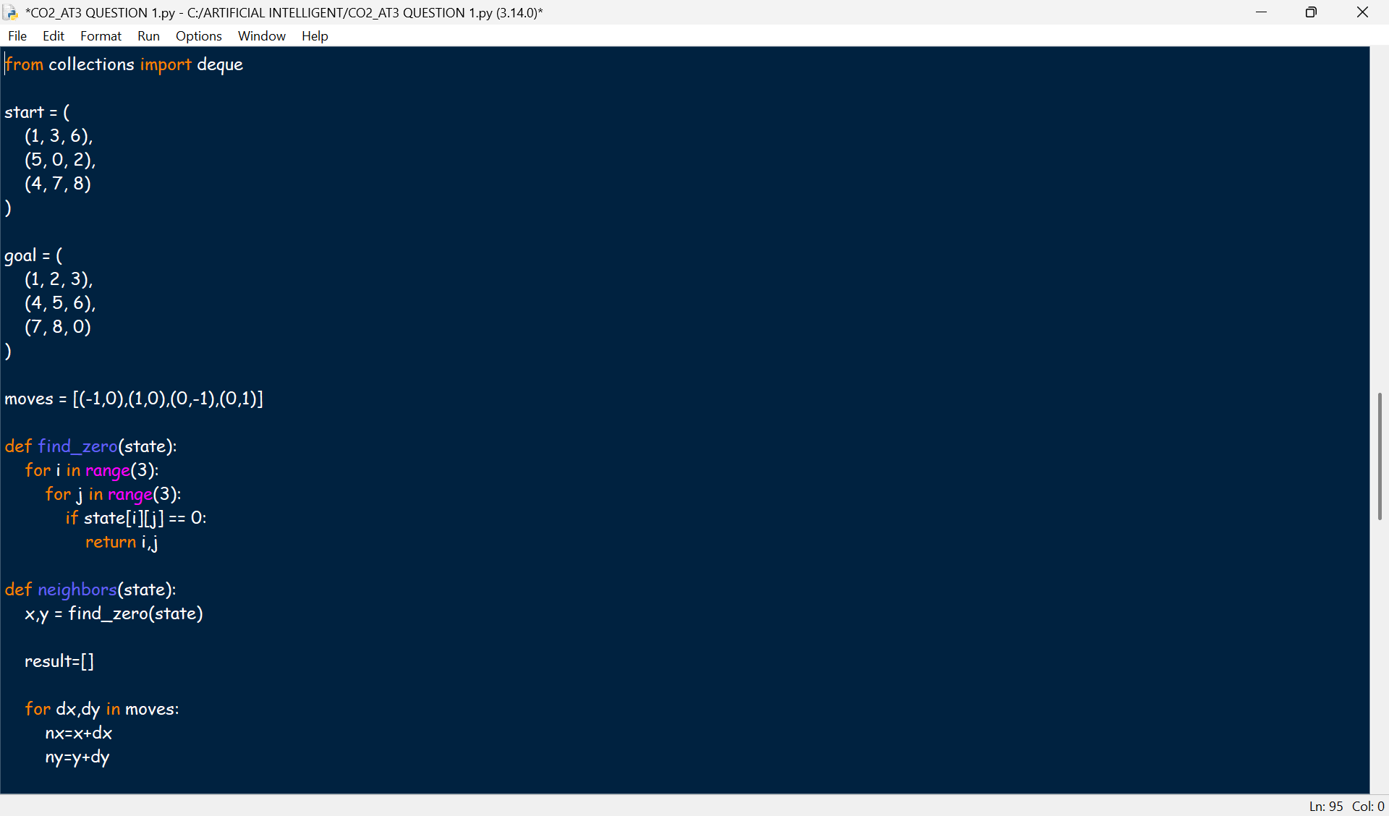
OUTPUT:
8-PUZZLE BFS DRY RUN
Iteration 1

Queue Before Expansion: 1

Current State
(1, 3, 6)
(5, 0, 2)
(4, 7, 8)

Queue After Expansion: 4
Iteration 2
Queue Before Expansion: 4

Current State
(1, 0, 6)
(5, 3, 2)
(4, 7, 8)

Queue After Expansion: 5
Iteration 3
Queue Before Expansion: 5

Current State
(1, 3, 6)
(5, 7, 2)
(4, 0, 8)

Queue After Expansion: 6
Iteration 4
Queue Before Expansion: 6

Current State
(1, 3, 6)
(0, 5, 2)
(4, 7, 8)

Queue After Expansion: 7
Iteration 5
Queue Before Expansion: 7

Current State
(1, 3, 6)
(5, 2, 0)
(4, 7, 8)

Queue After Expansion: 8

Total States Generated: 13

